meeting report 6.10

linyiguo

2019.6.10

Well, I did not send Aaron meeting report this time, cause I did not read much things recently, all content we talked was the things I have done before. And the meeting result compared with the former was better. I guess Aaron and I are getting used with each other? LOL.  
I hope to plot something to clearfy the point I want to express, but unfortunatly I can’t. I will add some photos in this folder.

# I

Note the curve of *trend + season* in **report 6.6** is pretty close to our data, which is totally opposite to the situation from StatCan… although I am not sure how they get the plot, at least I believe what I got is reasonable.  
Here is the thing, $Y_{t}−T_{t}−S_{t}$ is $ϵ_{t}$, and differences between our data and trend+season actually reflect the deviation of the noise $ϵ$. By controling the deviation of the noise, we can control the smoothness of the trend+season curve(since t.s $Y_{t}$ is fixed).

——————————————–**UPDATE 6.12**——————————————–  
昨天试着理清为什么Aaron说可以change $ω_{t}=ϕ(Y_{t}−T_{t}−S_{t})$ into $ω_{t}=ϕ(\frac{Y_{t}−T_{t}−S_{t}}{c})(c>1)$. But I still do not understand the theory behind it clearly… I give up temporarily :) Let’s see whether this could work in our s.s model before(*report 6.6*) ## change sd in expression of w from 1 to 5

library(seasonal)  
library(forecast)

## Registered S3 methods overwritten by 'ggplot2':  
## method from   
## [.quosures rlang  
## c.quosures rlang  
## print.quosures rlang

## Registered S3 method overwritten by 'xts':  
## method from  
## as.zoo.xts zoo

## Registered S3 method overwritten by 'quantmod':  
## method from  
## as.zoo.data.frame zoo

## Registered S3 methods overwritten by 'forecast':  
## method from   
## fitted.fracdiff fracdiff  
## residuals.fracdiff fracdiff

set.seed(1)  
  
# generate data  
model <- Arima(ts(rnorm(24000),freq=12), order=c(0,1,1), seasonal=c(0,1,1),fixed=c(theta=0.5, Theta=0.5))  
data <- simulate(model,nsim=240)  
  
# define m_x11  
m_x11 <- seas(data, x11 = "", regression.aictest = NULL)  
  
# Initialization  
S <- matrix(0,1000,251) # Cause Seasonal component's state space model, we have additional 11 zero-values.  
Tr <- matrix(0,1000,251)  
Tr[,11] <- data[1]  
S[,1:11] <- rep(as.numeric(data-final(m_x11))[1:11],1000)  
component <- c()  
a = 90 # a-11 is the length of our t.s.  
  
for (i in 12:a) {  
   
 # update particles  
 Tr[,i] <- Tr[,i-1] + rnorm(1000,sd=5)  
 for (j in 1:11) S[,i] <- S[,i]-S[,i-j]  
 S[,i] <- S[,i] + rnorm(1000,sd=5)  
   
 # update weights  
 w <- dnorm(data[i-11]-Tr[,i]-S[,i],sd=5)  
 w <- w/sum(w)  
   
 # evaluate state value  
 t <- sum(w * Tr[,i])  
 s <- sum(w * S[,i])  
   
 # add to our component path  
 component <- rbind(component, c(t,s))  
   
 # resample  
 Tr[,i] <- sample(Tr[,i], size =1000, replace = TRUE, prob = w)  
 S[,i] <- sample(S[,i], size = 1000, replace = TRUE, prob = w)  
}  
  
# plot four curves together  
plot(data[1:(a-11)],type = "l",ylim = c(-60,250),ylab='')  
par(new=TRUE)  
plot(component[,1],type="l",col="green",ylim = c(-60,250),ylab='')  
par(new=TRUE)  
plot(component[,2],type="l",col="blue",ylim = c(-60,250),ylab='')  
par(new=TRUE)  
plot(data[1:(a-11)]-component[,2],type="l",col="red",ylim=c(-60,250),ylab='')  
legend("topleft",c("data","trend","seasonal","deseasoned"),col=c("black","green","blue","red"),lty=c(1,1,1,1))

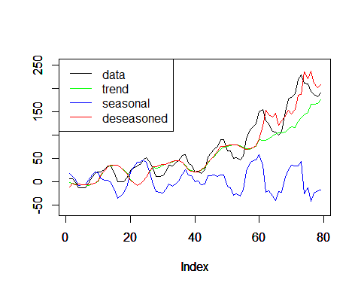

# data vs deseasoned  
plot(data[1:(a-11)],type = "l",ylim = c(-60,250))  
par(new=TRUE)  
plot(data[1:(a-11)]-component[,2],type="l",col="red",ylim=c(-60,250),ylab='')  
legend("topleft", c("data","deseasoned"),col=c("black","red"),lty=c(1,1))

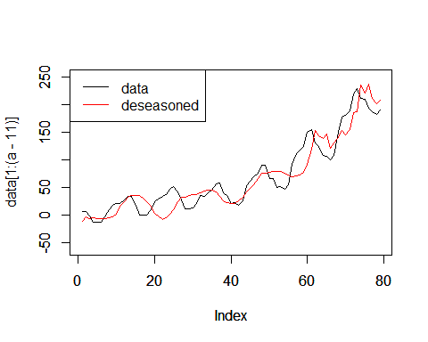

# data vs trend  
plot(data[1:(a-11)],type = "l",ylim = c(-60,250),ylab='')  
par(new=TRUE)  
plot(component[,1],type="l",col="green",ylim = c(-60,250),ylab='')  
legend("topleft",c("data","trend"),col=c("black","green"),lty=c(1,1))

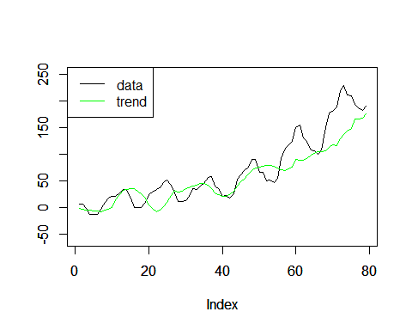

# data vs season  
plot(data[1:(a-11)],type = "l",ylim = c(-60,250),ylab='')  
par(new=TRUE)  
plot(component[,2],type="l",col="blue",ylim = c(-60,250),ylab='')  
legend("topleft",c("data","seasonal"),col=c("black","blue"),lty=c(1,1))

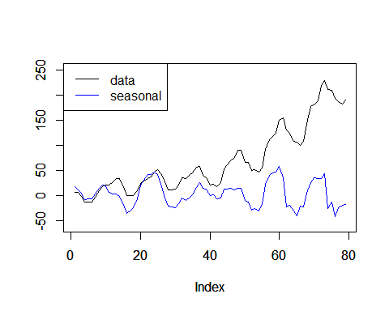

# data vs deseason&detrend  
plot(data[1:(a-11)],type = "l",ylim = c(-60,250),ylab='')  
par(new=TRUE)  
plot(data[1:(a-11)]-component[,1]-component[,2], type="l",col="red",ylim = c(-60,250),ylab='')  
legend("topleft",c("data","deseason&detrend"),col=c("black","red"),lty=c(1,1))

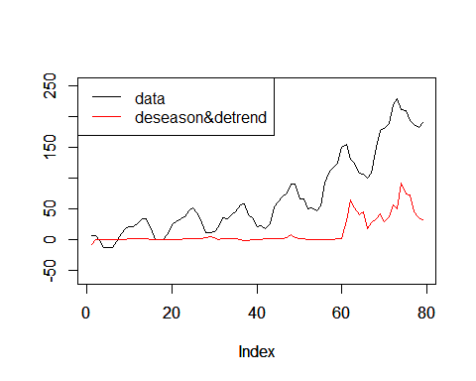

# data vs seanson+trend  
plot(data[1:(a-11)],type = "l",ylim = c(-60,250),ylab='')  
par(new=TRUE)  
plot(component[,1]+component[,2], type="l",col="red",ylim = c(-60,250),ylab='')  
legend("topleft",c("data","season+trend"),col=c("black","red"),lty=c(1,1))

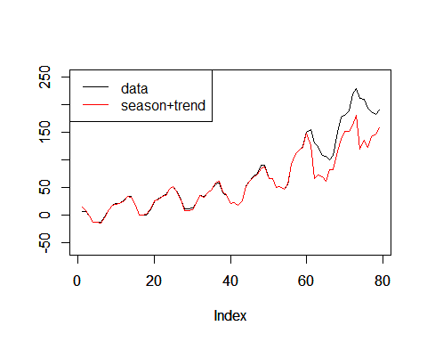

———————————————**UPDATE 6.16**———————————————  
I am busy with my resume and the self-recommendation letter recently… I need to meet aaron tmr, but for now I don’t have any things to show him, which is very very awkward… ## sd=20 in weights expression

# Initialization  
S <- matrix(0,1000,251) # Cause Seasonal component's state space model, we have additional 11 zero-values.  
Tr <- matrix(0,1000,251)  
Tr[,11] <- data[1]  
S[,1:11] <- rep(as.numeric(data-final(m_x11))[1:11],1000)  
component <- c()  
a = 90 # a-11 is the length of our t.s.  
  
for (i in 12:a) {  
   
 # update particles  
 Tr[,i] <- Tr[,i-1] + rnorm(1000,sd=5)  
 for (j in 1:11) S[,i] <- S[,i]-S[,i-j]  
 S[,i] <- S[,i] + rnorm(1000,sd=5)  
   
 # update weights  
 w <- dnorm(data[i-11]-Tr[,i]-S[,i],sd=20)  
 w <- w/sum(w)  
   
 # evaluate state value  
 t <- sum(w * Tr[,i])  
 s <- sum(w * S[,i])  
   
 # add to our component path  
 component <- rbind(component, c(t,s))  
   
 # resample  
 Tr[,i] <- sample(Tr[,i], size =1000, replace = TRUE, prob = w)  
 S[,i] <- sample(S[,i], size = 1000, replace = TRUE, prob = w)  
}  
  
# plot four curves together  
plot(data[1:(a-11)],type = "l",ylim = c(-60,250),ylab='')  
par(new=TRUE)  
plot(component[,1],type="l",col="green",ylim = c(-60,250),ylab='')  
par(new=TRUE)  
plot(component[,2],type="l",col="blue",ylim = c(-60,250),ylab='')  
par(new=TRUE)  
plot(data[1:(a-11)]-component[,2],type="l",col="red",ylim=c(-60,250),ylab='')  
legend("topleft",c("data","trend","seasonal","deseasoned"),col=c("black","green","blue","red"),lty=c(1,1,1,1))

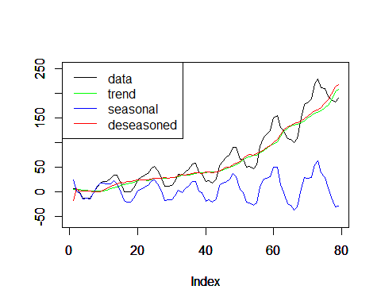

# data vs deseasoned  
plot(data[1:(a-11)],type = "l",ylim = c(-60,250))  
par(new=TRUE)  
plot(data[1:(a-11)]-component[,2],type="l",col="red",ylim=c(-60,250),ylab='')  
legend("topleft", c("data","deseasoned"),col=c("black","red"),lty=c(1,1))

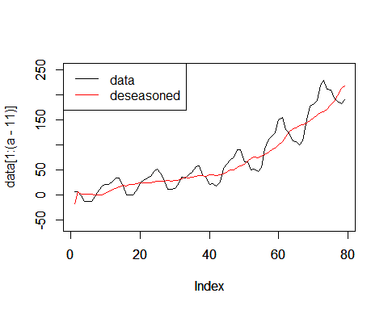

# data vs trend  
plot(data[1:(a-11)],type = "l",ylim = c(-60,250),ylab='')  
par(new=TRUE)  
plot(component[,1],type="l",col="green",ylim = c(-60,250),ylab='')  
legend("topleft",c("data","trend"),col=c("black","green"),lty=c(1,1))

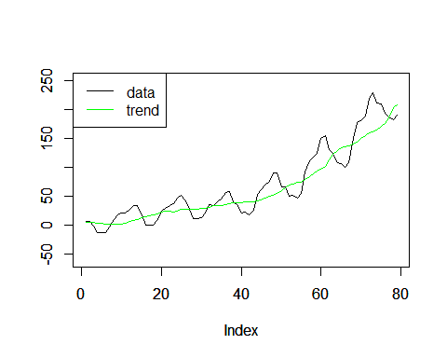

# data vs season  
plot(data[1:(a-11)],type = "l",ylim = c(-60,250),ylab='')  
par(new=TRUE)  
plot(component[,2],type="l",col="blue",ylim = c(-60,250),ylab='')  
legend("topleft",c("data","seasonal"),col=c("black","blue"),lty=c(1,1))

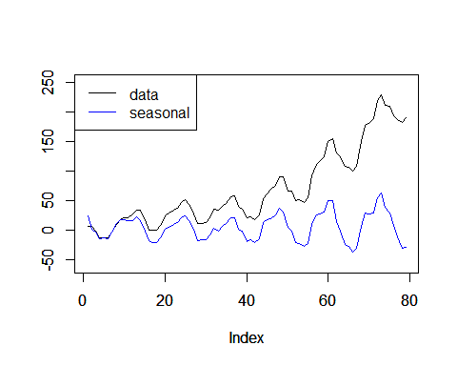

# data vs deseason&detrend  
plot(data[1:(a-11)],type = "l",ylim = c(-60,250),ylab='')  
par(new=TRUE)  
plot(data[1:(a-11)]-component[,1]-component[,2], type="l",col="red",ylim = c(-60,250),ylab='')  
legend("topleft",c("data","deseason&detrend"),col=c("black","red"),lty=c(1,1))

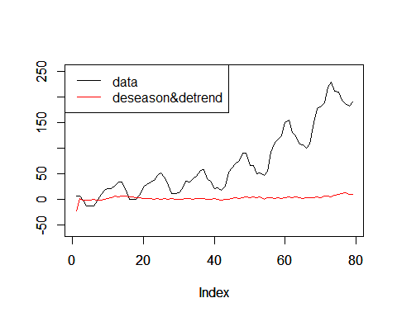

# data vs seanson+trend  
plot(data[1:(a-11)],type = "l",ylim = c(-60,250),ylab='')  
par(new=TRUE)  
plot(component[,1]+component[,2], type="l",col="red",ylim = c(-60,250),ylab='')  
legend("topleft",c("data","season+trend"),col=c("black","red"),lty=c(1,1))

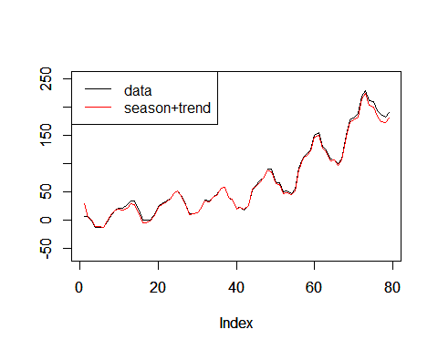

Well, after enlarging the deviation of noise, the curves of trend and deseasonal become much more smooth, which should be something like that from StatCan.

I think I should understand a little bit about why aaron told me to add a demoninator in weights expression. Like we said before, we can control the smoothness of our curves by controling the deviation of our noise. Let’s say we want

$$ϵ∼N(0,25)$$

which means

$$\frac{ϵ}{5}∼N(0,1)$$

or

$$\frac{Y_{t}−T_{t}−S_{t}}{5}∼N(0,1)$$

and

$$ω_{t}∝p(Y_{t}|T_{t},S_{t})$$

that is

$$ω_{t}∝ϕ(\frac{Y_{t}−T_{t}−S_{t}}{5})$$

And in R we can express $ϕ(\frac{Y_{t}−T_{t}−S_{t}}{5})$ in two ways:  
- dnorm((Y_t-T_t-S_t)\5)  
- dnrom(Y_t-T_t-S_t, sd=5)  
We choose the second one.